EXPERIMENT- 37
Play Video in Reverse Mode using OpenCV
Aim
To write a Python code to play a video in reverse mode using OpenCV video processing techniques.
Code
from google.colab import files
import cv2
from google.colab.patches import cv2_imshow
uploaded = files.upload()
video_path = list(uploaded.keys())[0]
cap = cv2.VideoCapture(video_path)
frames = []
while True:
ret, frame = cap.read()
if not ret:
break
frames.append(frame)
cap.release()
for frame in reversed(frames):
cv2_imshow(frame)
if cv2.waitKey(30) & 0xFF == 27:
break
cv2.destroyAllWindows()
Input & Output Video
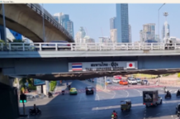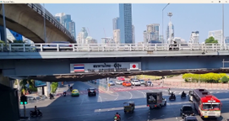
Result
Thus, the video was successfully played in reverse mode using OpenCV.

